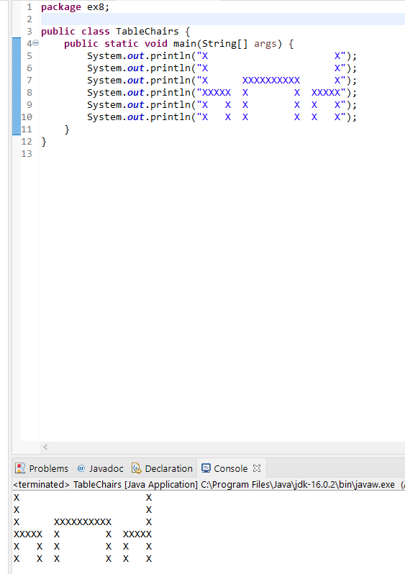These picture show my progress throughout the assignment and my successes in completing each excersize.



